**Name: Prithvi Agarwal**

**Sap: 500095094**

**BBA (Analytics & Big Data)**

**HOME**

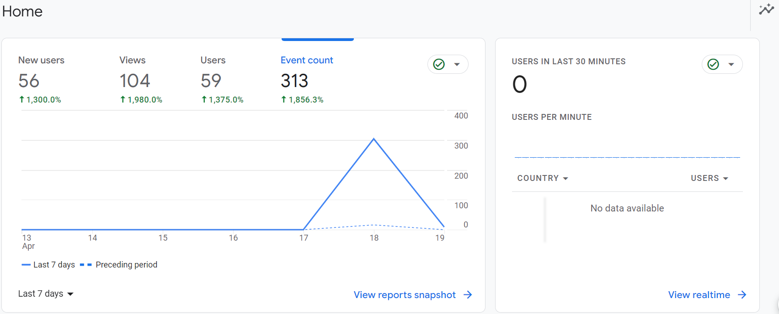

This image shows the number of new users, users, views, event count and also the users in the last 30 minutes where

Users: The Users and Active Users metrics show how many users engaged with your site or app.

New Users: A 'new user' is a visitor who, according to Google's tracking snippet, has never been to your site before and is initiating their first session on your site.

Views: A view is a set of specifications for tracking traffic on a single domain.

Event Count: The Event count by Event name card in the Realtime report shows you each triggered event and the number of times each event was triggered in the last 30 minutes by the users on your website or app.

**ENGAGEMENT**

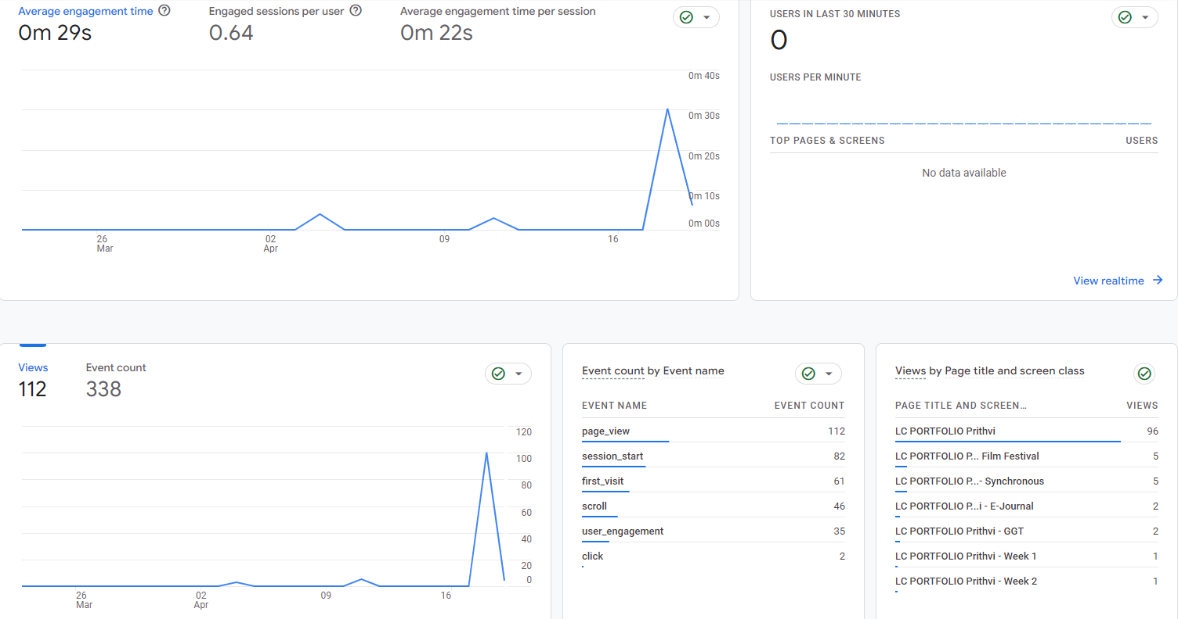Engagement Overview: The Engagement overview report is made up of individual cards that summarize engagement data from the engagement reports, including the Events report, Conversions report, Pages and screens report, and Landing pages report.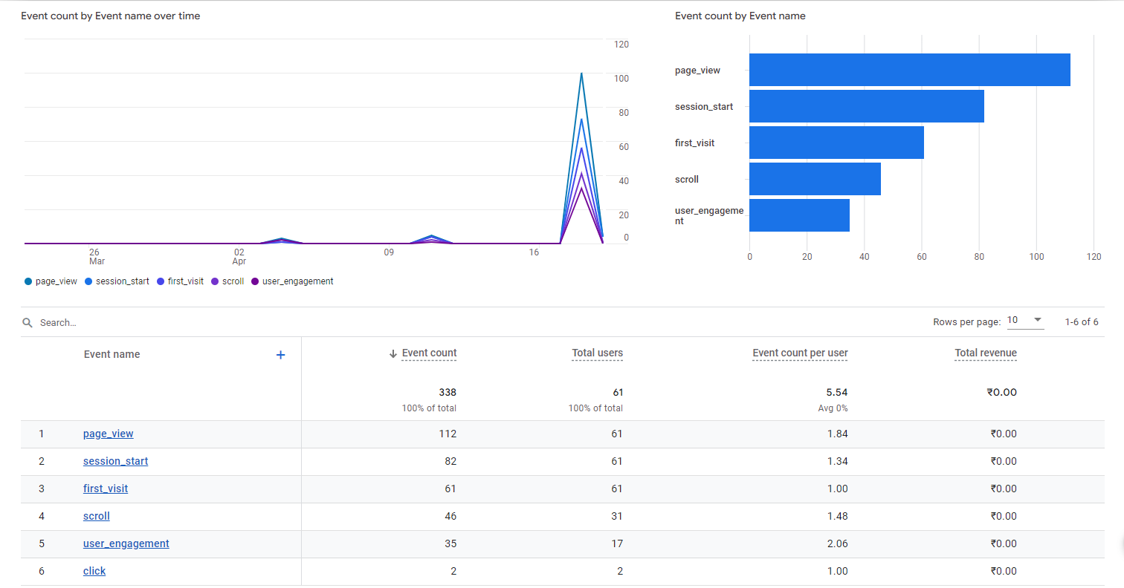Event: An event allows you to measure a specific interaction or occurrence on your website or app. For example, you can use an event to measure when someone loads a page, clicks a link, or completes a purchase, or to measure system behaviour, such as when an app crashes or an impression is served.

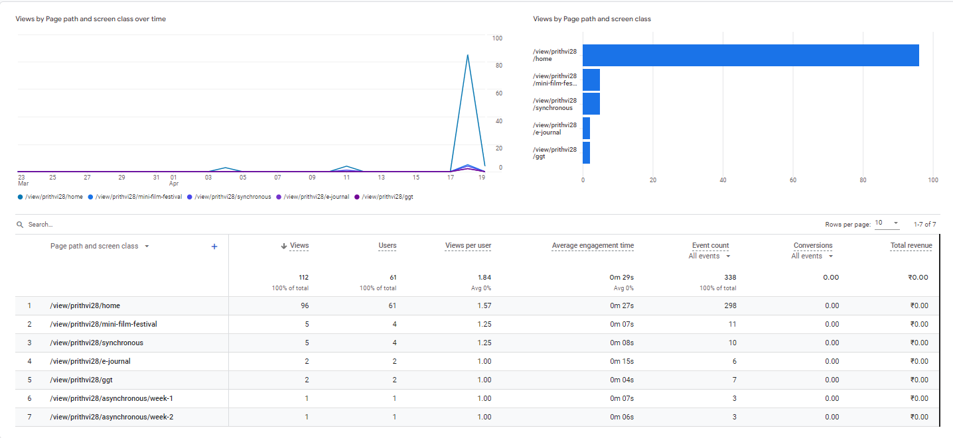Pages & Screen: The Pages and screens report shows the pages on your website and screens on your app that people visit and engage with

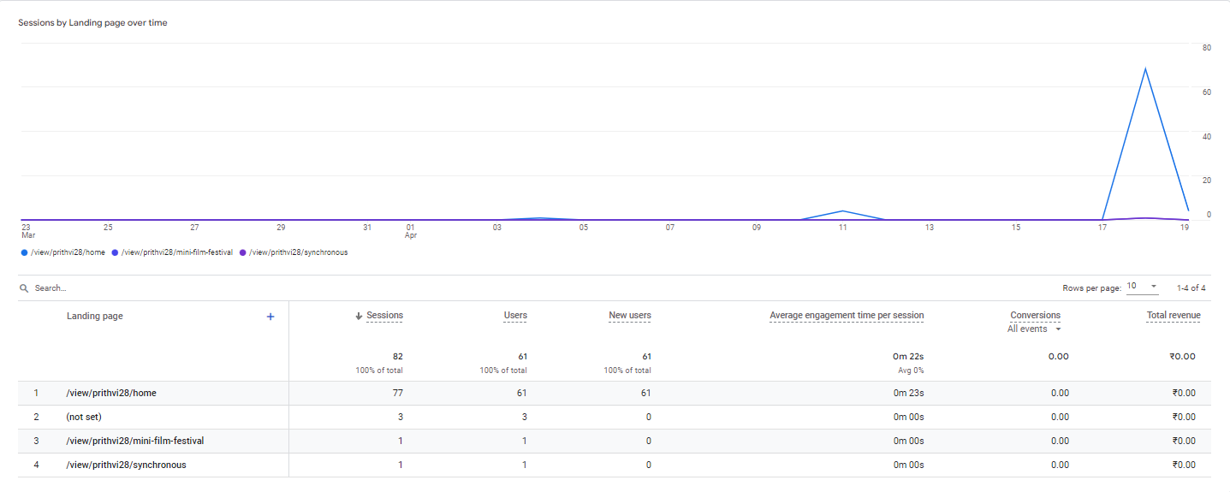

Landing Page: The Landing page report helps you understand how visitors interact with your website. It shows you the first page a visitor lands on when they visit your website and how many visitors land on each page. This information can help you identify which pages are performing well and which ones need improvement.

**ACQUISITION**

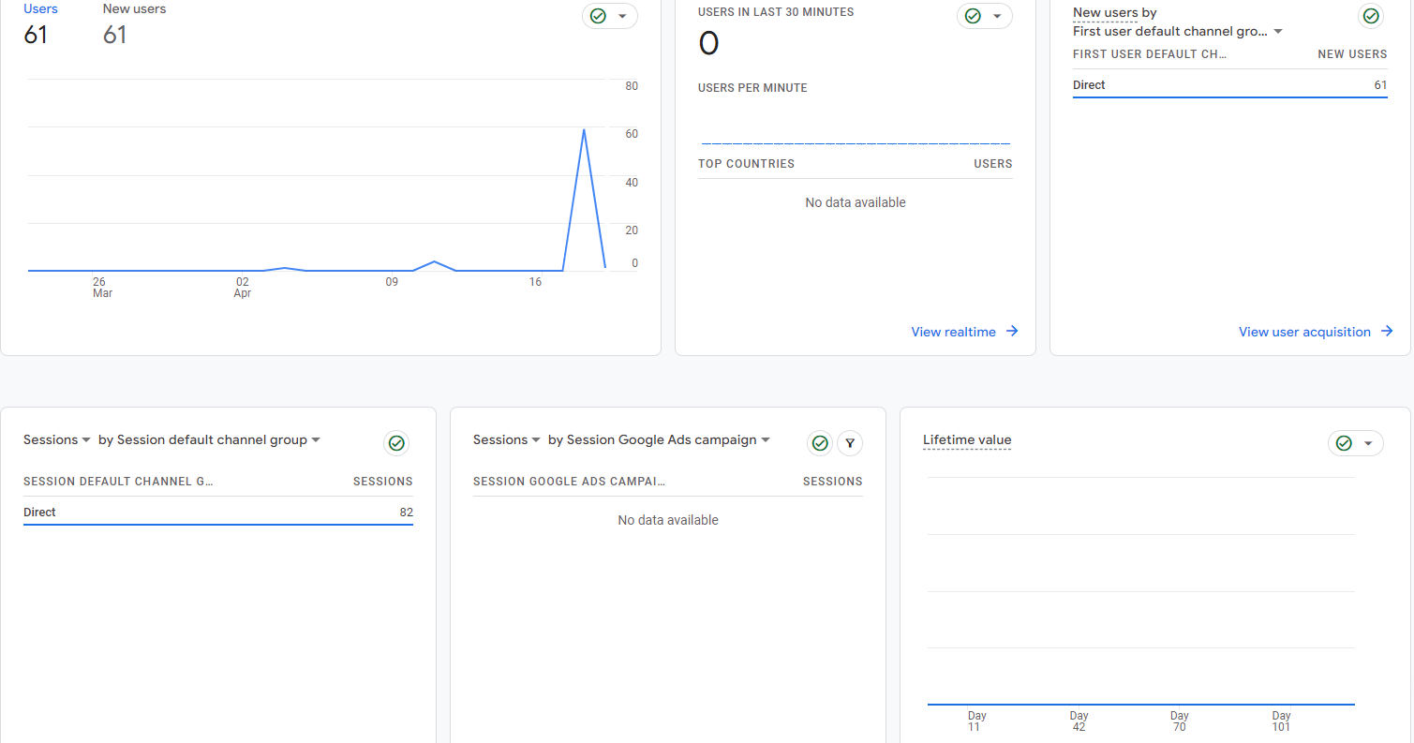Acquisition Overview: You can use the User acquisition report to get insights into how new users find your website or app for the first time. The report differs from the Traffic acquisition report, which focuses on where new sessions came from, regardless of whether the user is new or returning.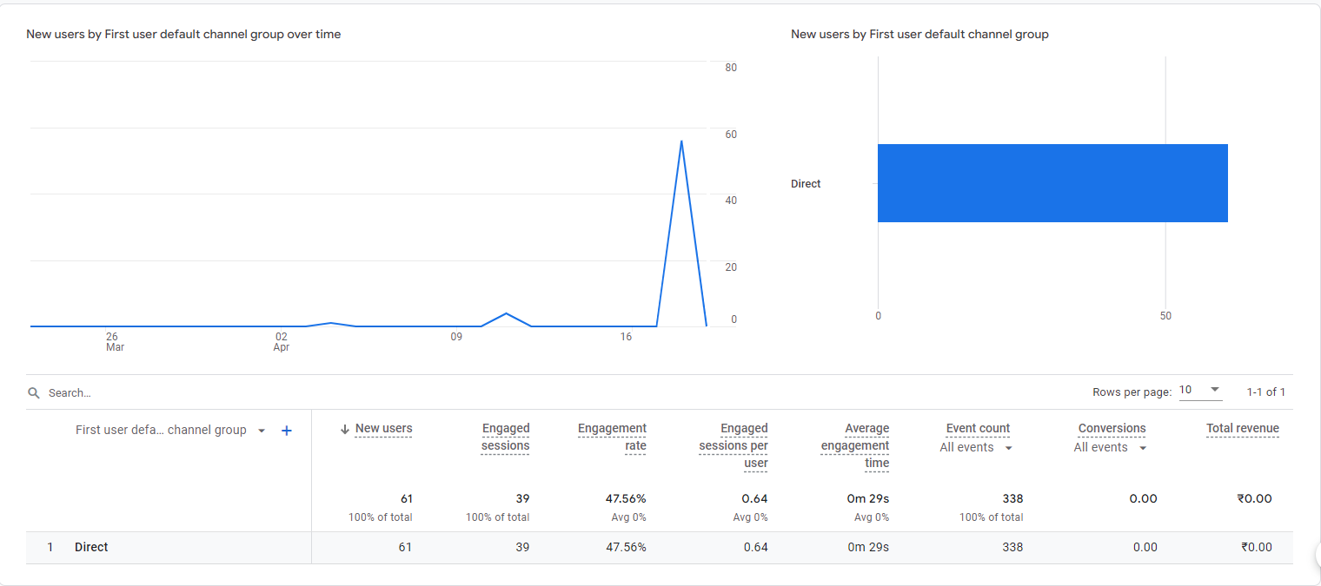

User Acquisition: You can use the User acquisition report to get insights into how new users find your website or app for the first time. The report differs from the Traffic acquisition report, which focuses on where new sessions came from, regardless of whether the user is new or returning.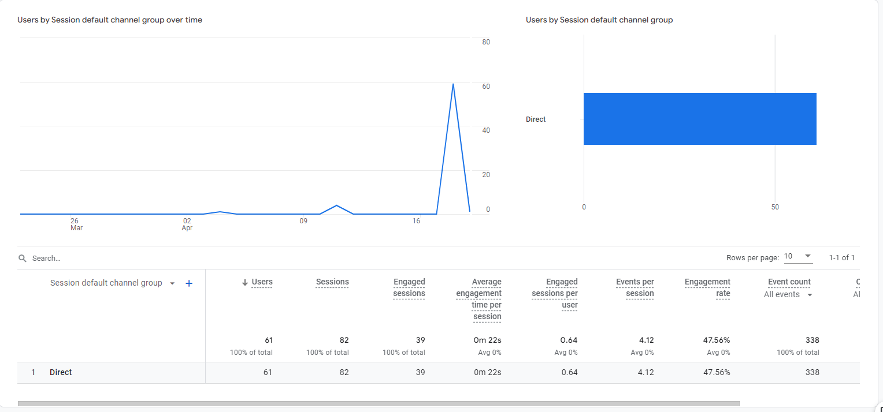Traffic Acquisition: You can use the Traffic acquisition report to get insights into where new sessions came from, regardless of whether the user is new or returning. The report differs from the User acquisition report, which focuses on the first session from a new user and excludes returning users.

**RETENTION**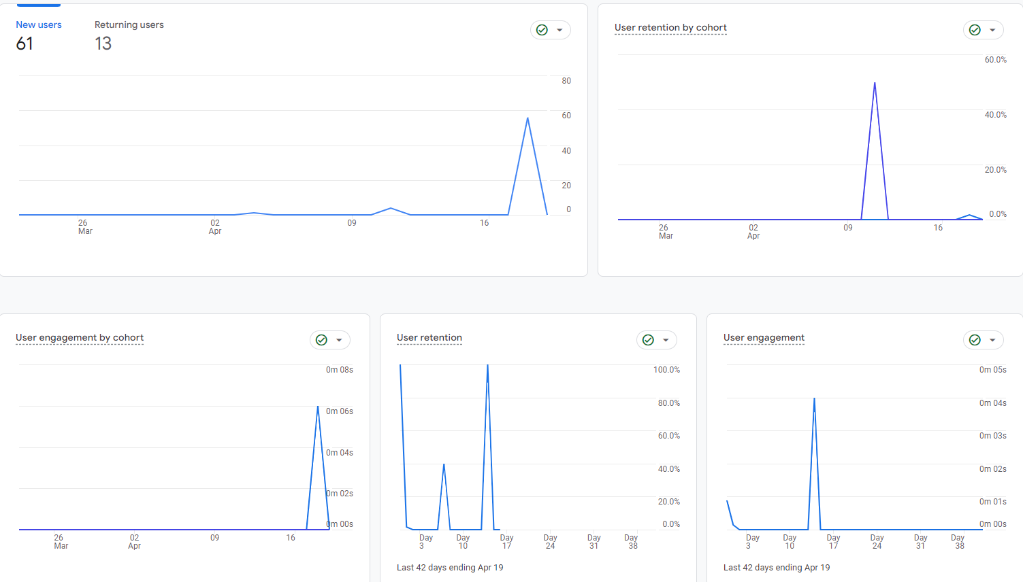Retention: The Google Analytics Data Retention controls give you the ability to set the amount of time before user-level and event-level data stored by Google Analytics is automatically deleted from Analytics servers.

**DEMOGRAPHICS**

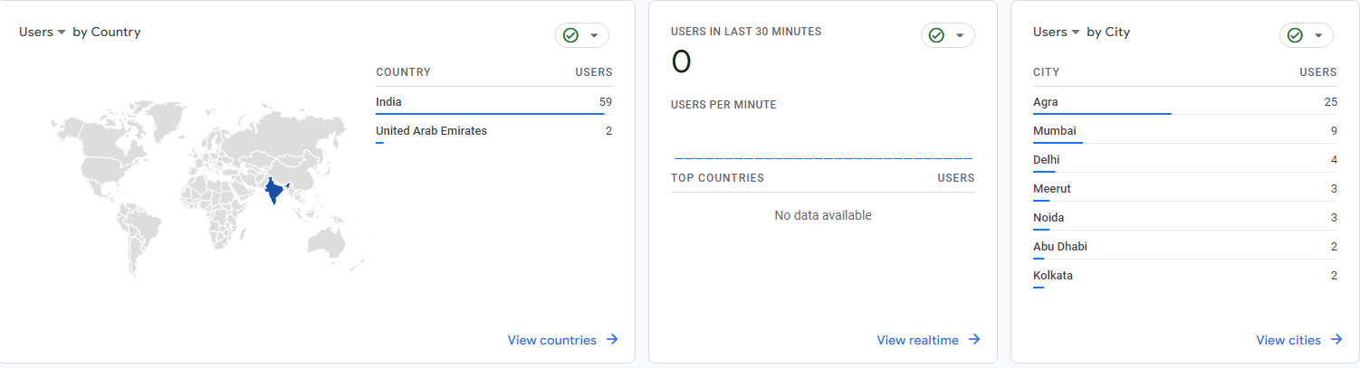

Demographic Overview: Analyse users by age, gender, and interest categories. Demographics and interests data provides information about the age and gender of your users, along with the interests they express through their online travel and purchasing activities.

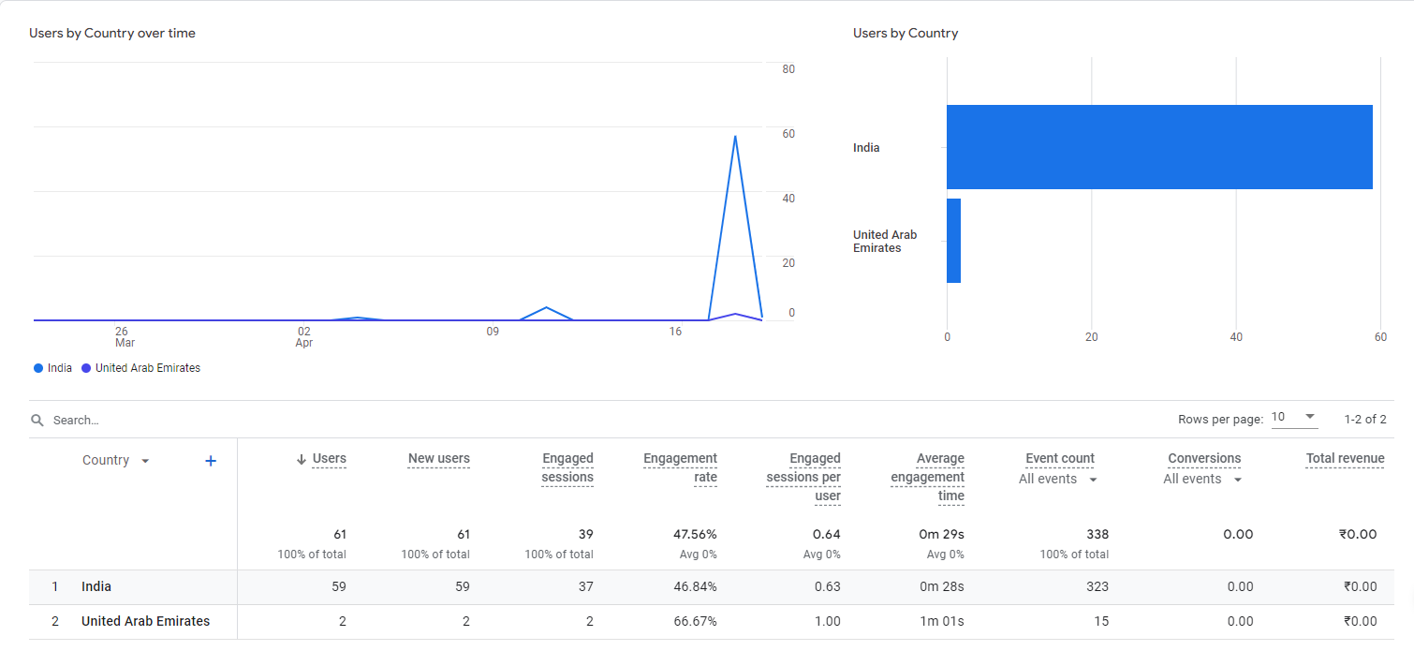

Demographic Details: Demographics and interests data provides information about the age and gender of your users, along with the interests they express through their online travel and purchasing activities.

**TECH**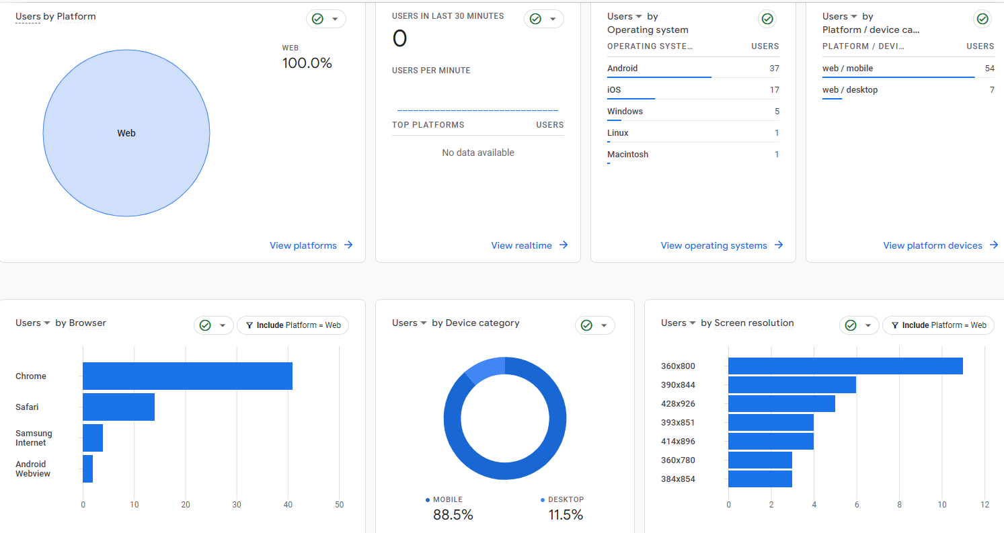Tech Overview: The Tech overview report in Google Analytics displays your app or website traffic by your visitor's technology, such as platform, operating system, screen resolution, and app version.

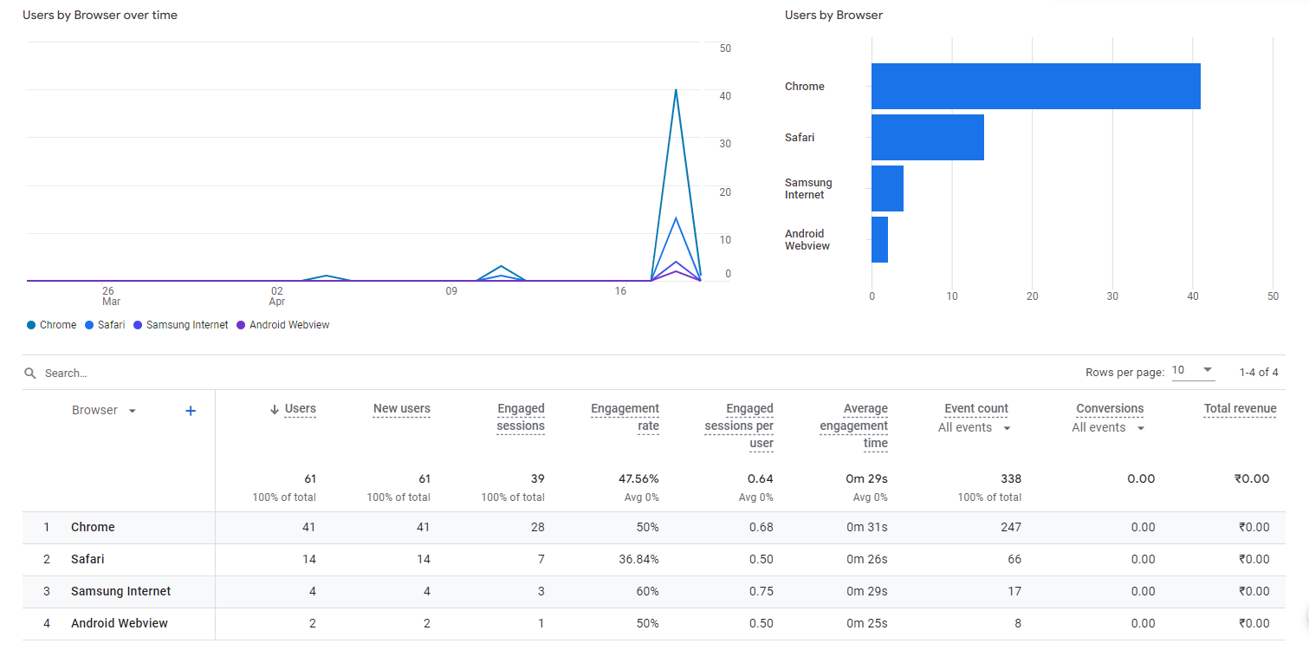Tech Details: The Tech overview report in Google Analytics displays your app or website traffic by your visitor's technology, such as platform, operating system, screen resolution, and app version. To access the Tech overview report, select Reporting from the drop-down menu in the top left of the Analytics interface.